Rambles Programme 2021
With Amended Dates for Malvern Hills Tour - Now 04th – 7th October

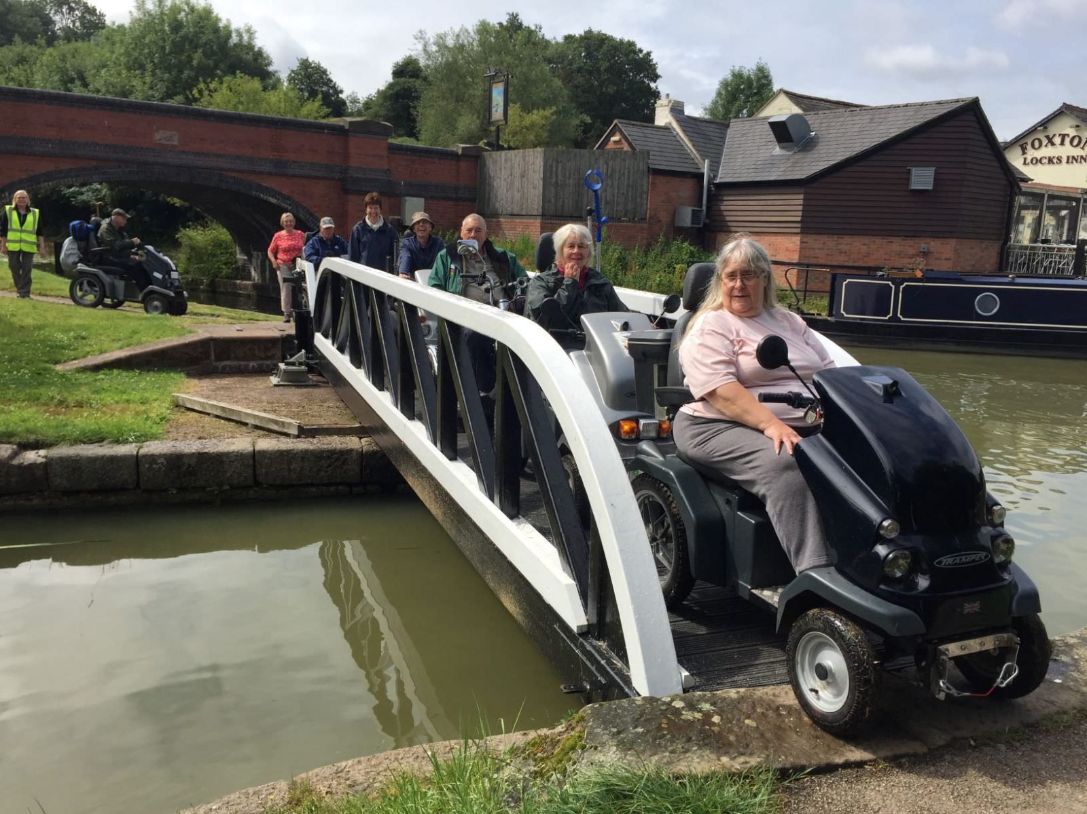
Foxton Locks 2019
Welcome. After a very different 2020 with no rambles, we are looking forward to what will hopefully be an exciting year of rambling with us. We hope you will find some rambles you are keen to join in 2021. Due to COVID 19 we have a reduced programme this year.
N.B: We need more ramble leaders across England and Wales. Training and help will be given. Please contact me if you would like to help in any way.
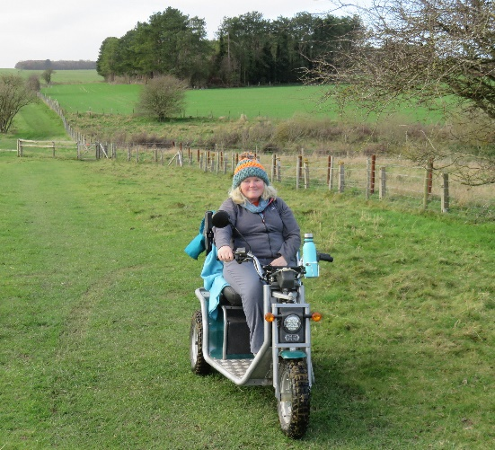
Paula Brunt,
Rambles Organiser
paula@disabledramblers.co.uk

Ramble Categories
Cat 1 is suitable for all wheelchairs etc. However, we rarely run Cat 1 rambles.
Cat 2 may include rougher surfaces and hills up to 1:8 and is suitable for robust outdoor powerchairs and medium scooters. However, the weather might cause the track to become muddy, slippery and covered in puddles. (Some very fit manual wheelchair users might cope with Cat 2 but consider the distance.) All Cat 2’s and Cat 2+ are suitable for a first ramble with the Disabled Ramblers.
Cat 3 means rough, stony and rutted surfaces with significant mud, cross-slopes and/or steep hills and is for experienced riders on robust off-road scooters. Cat 3- and Cat 3+ indicate easier or harder than Cat 3. Very few powerchairs are suitable for any Cat 3 rambles. Contact paula@disabledramblers.co.uk for advice if you think your powerchair would be suitable. Our preferred option is for you to use one of our Loan Scooters. Some Cat 3 rambles are suitable as a first ramble. If this is the case, it will state this next to the category type on the programme. Cat 3 rambles which have been assessed as being safe for a first ramble with us, should have no steep drop-offs at the side of the track and the steepness of hills and cross-slopes are not too severe.
If in doubt as to the suitability of your mobility vehicle, please contact me at paula@disabledramblers.co.uk to discuss.
Disclaimer & Consent
All participants take part at their own risk.
Dates and venues may occasionally need to be changed, sometimes at very short notice. We will make every endeavour to let members know if this is the case. Contacting you by mobile phone or email are the best options - please help us to help you by giving us an up-to-date email address and phone number – and on the booking form give contact details for the person you would wish to be contacted in emergency.
Signing-On at Rambles: Signing-On at Rambles: We aim to make our rambles as COVID 19 secure as possible, so instead of our usual signing-on process we will take a photo of all attendees as a record of attendance. Please note that by attending any ramble you are consenting too:
- taking part at your own risk;
- waiving all claims against The DISABLED RAMBLERS Ltd and its members howsoever arising, and to indemnify the Charity and its members against any claim due to negligence on your part;
- the use of your image – on a photo or in a video taken on this ramble – for our website, for our publicity and publications, and in our campaigning work. (Unless you wish to withhold consent for the use of your image, in which case you must let us know in writing when booking your place on the ramble.)

Essential COVID-19 information
We will try our very best to run the rambles advertised in this booklet on the dates advertised, however at the time of preparing this booklet, the Covid 19 situation is fluid and further restrictions could be introduced at any time and at short notice.
Booking accommodation
We advise that accommodation should not be booked until we have confirmed (as far as we are able to) that any particular Ramble Tour will proceed. Even then, you should check the refunds policy of your accommodation and/or take out appropriate travel insurance to protect you in the event of a Tour having to be cancelled at short notice. The Disabled Ramblers cannot accept any financial or other liability arising from the cancellation of rambles.
Booking rambles
We will only take provisional ramble bookings in the first instance, and will ask for payment when we send you the joining instructions about 2 weeks before the start of each Tour when we are as certain as we can be that the rambles can go ahead.
You must not attend any ramble if:
- you are showing any of the main COVID 19 symptoms or have tested positive. The main symptoms are:
  - a high temperature – this means you feel hot to touch on your chest or back (you do not need to measure your temperature)
  - a new, continuous cough – this means coughing a lot for more than an hour, or 3 or more coughing episodes in 24 hours (if you usually have a cough, it may be worse than usual)
  - a loss or change to your sense of smell or taste – this means you've noticed you cannot smell or taste anything, or things smell or taste different to normal
- you have recently been in contact with someone showing any of the main COVID 19 symptoms, or if they have tested positive
- you are coming from outside the area and your local area is in a Tier that is in local lockdown and prevents you going into another Tier (Tier 4 at time of issue) or under COVID 19 restrictions
- you have been asked to quarantine or self-isolate
On the day of the ramble you must:
- keep at least 2 metres / 6 feet from anyone else at all times (unless that person is part of your household or bubble) – remember that anyone could be asymptomatic and infectious
- carry a Face Covering and use it if the need for a close encounter occurs
- provide your own Hand Sanitiser and use it
Ramble Information. Joining Instructions are sent to members 2 -3 weeks prior to each ramble. In the meantime, for queries about a ramble, please contact: Paula Brunt, Rambles Organiser. 07748 636365. paula@disabledramblers.co.uk
Membership. For any queries or comments about membership please contact:
Bee de Rivaz, Assistant Membership Secretary, membership@disabledramblers.co.uk
Bookings. Provisional Bookings open on 15th February 2021. Please send your bookings to: Rhiannon Robinson, Bookings Secretary, bookings@disabledramblers.co.uk or by post to 43 Elm Lodge Rd, Wraxall, Bristol BS48 1JG. For Queries only please phone 01275 854500.

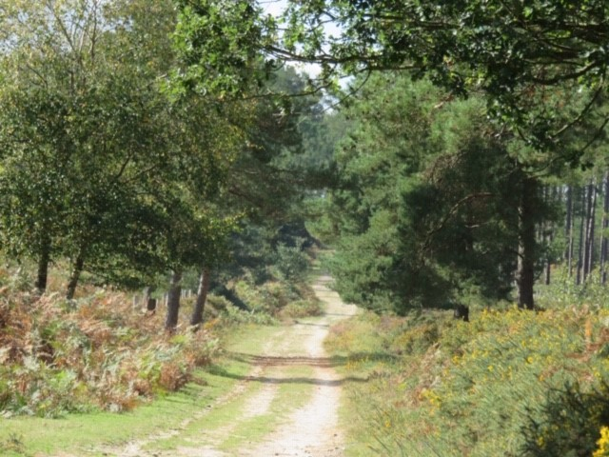
The Sika Trail

The 2021 Rambles Programme
Dogs: If you are considering bringing your pet dog, please check the information under each ramble entry.
Accredited Assistance Dogs are not bound by any of these restrictions or limitations, and may be present on any of our rambles; please do not distract these working dogs, and ask permission from the owners first if you want to talk to their dogs.
Link to Map of all Ramble Locations on Google Maps
2021 Rambles Locations – Google My Maps
Overview of the year – Please note these dates are provisional.
Accommodation should not be booked until advised to do so.
At the time of preparing this booklet, the Covid 19 situation is fluid and further restrictions could be introduced at any time and at short notice. We advise therefore, that accommodation should not be booked until we have confirmed (as far as we are able to) that any particular Ramble Tour will proceed. Even then, you should check the refunds policy of your accommodation and/or take out appropriate travel insurance to protect you in the event of a Tour having to be cancelled at short notice. The Disabled Ramblers cannot accept any financial or other liability arising from the cancellation of rambles for reasons outside its control.
*Please note New Dates For Malvern Hills*
Dates | Locations | Pages
June 7th, 8th, 10th, & 11th | Herts & Essex | 5
July 5th, 6th, 8th & 9th | Dorset | 9
September 6th, 7th, 9th & 10th | Leicestershire | 10
October 4th, 5th, 7th & 8th | Malvern Hills

Herts & Essex Tour: Leaders - Bee & Mark de Rivaz
2101 – Lee Valley Regional Park, EN9 1AB Monday 7th June
A gentle and easy ramble, mostly on surfaced and level paths. Starting at the Lee Valley White- Water Centre (home of the white-water events in the 2012 Olympics), we meander through the 1,000-acre wetland park on the northern edge of London. Our route takes us past lakes, along part of the River Lea Navigation towpath, through grassland and meadows; the Park is a haven for all manner of wildlife, including otters and especially birds. After the ramble, enjoy a cup of tea or a drink at The Terrace Café and watch the activities on the white-water course.
Dogs: Welcome, on leads where necessary or signed. NB the Park is popular with cyclists and walkers, especially parents with small children /buggies.
Nearest Town: Waltham Cross 2 Miles 6.5 Miles, Cat 2 Suitable as first ramble
Surface: Mostly level and hard surfaced paths. A short stretch along a canal side towpath – no barrier so concentration needed
Scooter: Suitable for most robust power chairs and mobility vehicles with batteries that are capable of doing the distance.

2102 – Epping Forest, IG10 4AE Tuesday 8th June
Epping Forest stretches over 12 miles from east London into Essex and covers over 2,500 hectares (nearly 6,200 acres). A former Royal Forest, it was used by Kings and Queens of England as a hunting ground.
We will ramble on mostly surfaced tracks, starting with the appropriately named (and fairly steep) Ups and Downs. We move through forest paths and alongside grazing land to the beautiful Connaught Water, where we stop for lunch. Our return journey takes us past Queen Elizabeth’s Hunting Lodge, dating from 1543, through the historic parkland and flower-rich meadows. Look out for some of the internationally important ancient trees, some more than 1,000 years old, along the way.
Dogs: Welcome, on leads where necessary or signed.
Nearest Town: Waltham Cross 7 miles 6.5 Miles, Cat 2 Suitable as first ramble
Surface: Mostly firm, flat woodland tracks, some steeper uphill and downhill near the start. 2 busy road crossings.
Scooter: Suitable for all terrain mobility vehicles such as Supersport and Trampers.

2103 – Hunsdon Airfield Loop, SG12 8PB Thursday 10th June
We start by crossing the site of the former WW2 Hunsdon Airfield, now largely used as arable farmland, but also home to the Hunsdon Microlight Club. RAF Hunsdon became operational in 1941. It was particularly noted for its squadrons of de Havilland Mosquito fighter-bombers, and for being the base from which Operation Jericho (the Amiens Prison Raid) was launched in February 1944. We will stop briefly at the memorial to the 126 air and ground crew who died while flying from or serving at the base – many from Australia and New Zealand.
From the airfield we pass by and through woodland and along farm tracks. We also follow field edges and paths through arable crops (some of which can be quite rough and bumpy) towards Cockrobin Lane, a charming ancient green lane, providing shade and shelter before we return to the open landscape of the airfield, which we then cross by a different route to return to the parking area. This makes for a varied and interesting ramble.
Dogs: Welcome, may need to be on leads where necessary or signed.
Nearest Town: Harlow 5 Miles 6.5 Miles, Cat 3 Suitable as a first ramble
Surface: The paths on this ramble are varied; concrete, rubble, grass, field edges and across arable fields, some smooth and some very bumpy, with a few inclines.
Scooter: Suitable for all terrain mobility vehicles such as Supersport and Trampers.

2104 – Hatfield Forest and Flitch Way, CM22 6NH Friday 11th June
Hatfield Forest is the best surviving example in Britain of an almost complete Royal Hunting Forest, declared as such by Henry I in 1100. It was acquired by the National Trust in 1923. It is a managed landscape, created by centuries of human intervention and continues to be managed with traditional woodland techniques of coppicing, pollarding and grazing. The wood pasture is a rare habitat in the UK.
Our ramble takes us in a figure of eight from the Café and Visitor Centre by the lake, along a mix of surfaced pathways, broad grassy rides and narrower woodland paths. We pass the Portingbury Hills Iron Age settlement and the site of the Doodle Oak. Continuing through Hangman’s Coppice, we leave the Forest and continue for about a mile along the firm-surfaced Flitch Way, a linear country park which follows the line of the former Bishop’s Stortford to Braintree railway line, before returning to the coppices and rides of the Forest. After stopping for lunch at the Café area, we resume our ramble around the southern part of the Forest, finally passing through Collin’s Coppice before returning to the Café and Visitor Centre.
Dogs: Welcome, may need to be on leads where necessary or signed.
Nearest Town: Bishop Stortford 6 Miles 6.5 Miles, Cat 2 Suitable as first ramble
Surface: Mostly level, including compacted gravel, grass and woodland tracks can be slippery if wet.
Scooter: Suitable for all terrain mobility vehicles such as Supersport and Trampers.

Dorset Tour: Leaders - Paula & Pete Brunt

2105 – The Sika Trail, BH20 7PE Monday 5th July
The Sika Trail is a cycle route through Wareham Forest. The route is mainly on good forest paths with some smaller single-track paths in part of the forest. We go along the edge of Morden Bog, but not in it! The route is very pretty with varied forestry and some views over the countryside. Look out for Sika deer and wood larks.
Dogs: Welcome.
Nearest Town: Wareham 1 mile 8 Miles, Cat 3 Suitable as first ramble
Surface: This is part of a cycle route so there will be cyclists. One steepish section which could be slippery when wet. A little bumpy on the single-track path in the woods. Boggy areas off some of the paths.
Scooter: Suitable for all terrain mobility vehicles such as Supersport and Trampers.

2106 – Old Harry Rocks to the Obelisk, BH19 3AU Tuesday 6th July
This is a linear route starting from the South Beach carpark, a short walk down the road. We then wind our way up a track. This is bumpy in places but only for a couple of 100m. The path then opens up onto a wider path leading up to the cliffs. Stunning views of Old Harry at the top as well as The Pinnacles. We then continue onto Ballard Down with views across to Swanage and on to the obelisk. We return the same way, but taking in the views of Poole. At the end of the ramble we go to Manor Farm café for tea and cake.
Dogs: Welcome on leads, due to cattle and cliff edges
Nearest Town: Wareham 11 Miles 7 Miles, Cat 3
Surface: The start of the ramble is approx. 200m on a quiet country road. Some bumpy paths with rocks at the start. Cliff edges with long drops so please keep well back.
Scooter: Suitable for all terrain mobility vehicles such as Supersport and Trampers.

2107 – Nine Barrow Down, BH20 5JG Thursday 8th July
Nine Barrow Down is a linear route on the Purbeck Ridgeway. At the start of the ramble we will make our way up through farmland and up onto the ridge. We will head towards the Corfe Castle where the views of the castle are spectacular. We then head back along the ridge taking in coastal views of Poole Harbour and Swanage. You will also be able to see round barrows and a long barrow. Might need to wrap up warm as it can get very windy!
Dogs: Welcome, but will need to be on leads in fields with cattle
Nearest Town: Wareham 6 Miles 6.5 Miles, Cat 3
Surface: Parts of the track can be bumpy. However mostly on grass. There are sheer drops on the Corfe Castle side of the ramble.
Scooter: Suitable for all terrain mobility vehicles such as Supersport and Trampers.

2108 – RSPB Arne, BH20 5BJ Friday 9th July
Arne is a very pretty nature reserve run by the RSPB. For birdwatchers this is a great little ramble. You will be rambling through the woods and heathland and if you’re lucky you may even see a Sika deer. They are very shy, but if we’re lucky we may get a glimpse. On our reccy we managed to catch a glimpse of a couple of them. We will be going down to the beach, where we can see what wetland birds are around, a couple we saw on our visit were oystercatchers and giant white egrets (please note, we aren’t allowed on the sand with scooters due to soft sand).
Dogs: Welcome, but must be kept on a lead at all times, due to the nature of the site.
Nearest Town: Wareham 4 Miles 5 Miles, Cat 3
Surface: If wet some of the paths are muddy and can be slippery. There are also some narrow paths
Scooter: Suitable for all terrain mobility vehicles such as Supersport and Trampers

Leicestershire Tour: Leaders - Judy & Bernard Cunningham
2109 – Elvaston Castle Country Park DE72 3EN Monday 6th September
Elvaston Country Park has, for the sixth year running, earned the Green Flag Award, the national standard for parks and green spaces in England and Wales, for its quality green-space provision. At the heart of the estate lies Elvaston Castle, a gothic revival masterpiece (not open to the public) designed by James Wyatt in the early 1800s based on the original house dating back to 1633. Our ramble takes us around the lake where there is an abundance of wide life. Venturing through the park we pass enchanting rockwork structures, topiary and tree lined avenues and head out of the park towards the River Derwent where we stop for our morning coffee break overlooking a weir, returning to the Castle grounds for lunch. Afterwards we pass through the Parterre and Italian gardens and then out through the Golden Gates. Passing the Old English Garden, we follow the pathways, and open spaces back to the car park.
Dogs: Welcome, but may need to be kept on a lead at times, due to the nature of the site.
Nearest Town: Derby 7 Miles 7 Miles, Cat 3- Suitable as 1st Ramble
Surface: Firm gravel, can be muddy in places under trees and around lake
Scooter: Suitable for all terrain mobility vehicles such as Supersport and Trampers.

2110 - Calke Abbey and Staunton Harold Reservoir DE73 7JF Tuesday 7th September
This tranquil ramble takes us along part of the route of the historic horse drawn Tramway trail and through the parkland of Calke Abbey. The route passes varied landscapes of grass lands, arable farmland and wildlife including Red and Fallow deer. We pass close to the Abbey and also visit and pause at Staunton Harold Reservoir to admire the splendid views.
Dogs: Dogs welcome in the park on a lead especially near livestock.
Nearest Town: Ashby-de-la-Zouch 7 Miles 7 Miles Cat 3- Suitable as 1st Ramble
Surface: Grass tracks, tarmac roads, gravel paths which can be muddy and uneven in places
Scooter: Suitable for all terrain mobility vehicles such as Supersport and Trampers.

2111 – Beacon Hill Country Park LE12 8TA Thursday 9th September
Beacon Hill Country Park, close to Woodhouse Eaves, is owned and managed by Leicestershire County Council. Rising to a height of 245m, Beacon Hill is one of the highest points in Leicestershire and boasts spectacular views of Charnwood Forest and the Soar Valley. Covering 128ha, the Country Park consists of mixed woodland, grassland, open heathland, wetlands and rocky outcrops. The Park supports an important range of plants and animals, and is part of the 'Beacon Hill, Hanging stone and Outwoods' Site of Special Scientific Interest (SSSI). The management of the park aims to balance public access with the need to maintain and enhance the habitats for which the site is important. As a result, Beacon Hill Country Park was the recipient of the 1996 English Nature Award for Management. The ramble also incorporates Broombriggs Farm Trail and Windmill Hill
Dogs: Welcome, but must be kept on a lead at all times, due to the nature of the site.
Nearest Town: Loughborugh 5 Miles 6 Miles, Cat 3
Surface: Mainly gravel surfaces, some sections of uneven surfaces which can be muddy. 2 short sections of uneven inclines which require care.
Scooter: Suitable for all terrain mobility vehicles such as Supersport and Trampers.

2112 – Donisthorpe Woodland Park & Moira Furnace DE12 7PX Friday 10th September
Donisthorpe Woodland Park was created on the former Donisthorpe Colliery; the site has been reclaimed to create a picturesque new landscape which is now part of The National Forest. This area of approximately 50 acres has been planted with around 74,000 trees including native oak, ash and Corsican pine. The surface paths are suitable for all abilities, as it meanders around this beautifully transformed site. The route incorporates part of the Ashby Woulds Heritage Trail linking Measham, Conkers Waterside and Moira Furnace along the restored Ashby canal.
Dogs: Welcome, but must be kept on a lead at all times, due to the nature of the site.
Nearest Town: Ashby-de-la-Zouch 4 Miles 5 Miles, Cat 2+ Suitable as 1st ramble
Surface: Tarmac sections, gravel and uneven grass tracks
Scooter: Suitable for all terrain mobility vehicles such as Supersport and Trampers.

Malvern Hills Tour: Leader - Arthur Lee
2113 – West of England Quarry to North Hill, WR14 4DG Monday 4th October
From the car park a narrow path leads steeply to 'The Gold Mine' where we join the ridge which forms the boundary between Herefordshire and Worcestershire giving great views for the rest of the ramble.
Climbing steadily, we reach the summit of Worcestershire Beacon – the highest point in Worcestershire at 425 metres / 1,400 feet.
Descending to the north, we pass the Sugarloaf Col with its stone direction marker mound and the path flattens out. Following a good wide track, we circle North Hill until it descends to West Malvern Road and our lunch stop at the Sugarloaf Café.
After lunch our route climbs back up to the direction stone mound on Sugarloaf Col. The rest of our route is a reverse of the morning’s path.
Dogs: Welcome. There may be sheep or cattle anywhere on the hills but the area will be fenced and warning given if they need to be on a lead.
Nearest Town: Malvern 3 miles 5 Miles, Cat 3- Suitable as first ramble
Surface: A bit rough and rutted for a 100m near the start and similarly for about 200 metres beyond Worcestershire Beacon. Otherwise, compacted gravel. There are some steep drop-offs down the side of the hill but the paths are generally wide.
Scooter: Suitable for large off-road mobility scooters such as Supersports & Trampers.

2114 – Gardiner’s Quarry to Broad Down, WR13 6DN Tuesday 5th October
From Gardiner’s Quarry the route climbs steeply on rough track to the ridge at ‘Little Switzerland’. After enjoying the view to the east, we follow the line of the ridge south on the Herefordshire side of the hills to Black Hill. Soon there is an accessible toilet near to British Camp car park. Crossing the A449 with care we follow a path on the Worcestershire side of the British Camp hill all the way to Broad Down and Hangman’s Hill for our lunch stop overlooking the Severn Plain, Bredon Hill and the Cotswolds.
Dogs: Welcome. There might be sheep or cattle anywhere on the hills but the area will be fenced and warning given if they need to be on a lead.
Nearest Town: Malvern 3 Miles 5 Miles, Cat 3- Suitable as first ramble
Surface: Steep and rocky at start. Section of cross-slope which should be avoided by taking the higher path at the col just after Pinnacle Hill. Cross the A449 with care.
Scooter: Suitable for large off-road mobility scooters such as Trampers and Supersports.

2115 – Golden Valley Mill Pond to Eastnor Obelisk, WR13 6AA Thursday 7th October
From the Mill Pond on Castlemorton Common, the ramble takes us across the common (might be muddy) and up to the Gullet Quarry lake. The area looking down on the Gullet Quarry Lake makes a great coffee stop.
Take great care on the track up The Gullet as it is very rough and there is a drop off! Once at the top it is not far to our lunch stop at the Obelisk with its fine views across Herefordshire.
Dogs: Welcome. There might be sheep or cattle anywhere on the hills but the area will be fenced and warning given if they need to be on a lead.
Nearest Town: Malvern 7.5 Miles 5.5 Miles, Cat 3+
Surface: It can be muddy crossing the commons. The Gullet Pass is steep and rocky with a drop-off to one side towards Gullet Stream.
Scooter: Suitable for all terrain mobility vehicles such as Supersports & Trampers.

2116 – Hollybush to Bromsberrow, HR8 1EX Friday 8th October
From All Saints Church near Hollybush we take an ancient sunken track, before turning south and passing under Ragged Stone Hill. Continuing through old woods we come to the Bromesberrow Estate where the lake makes a great lunch stop.
A short section of road leads to the climb up Chase End Hill where there are great views all around.
After passing through the hamlet of Whiteleaved Oak, the route re-joins the outward leg back to the car park at All Saints Church.
Dogs: Welcome. They may need to be on leads at times as there could be sheep or cattle anywhere on the hills.
Nearest Town: Malvern 9 Miles 5.5 Miles, Cat 3
Surface: Generally compacted gravel or grass. 300 metres along sunken green lane is rough and can be soft in places. Short steep climb at one point. There might be a VERY large bull in one field together with cattle.
Scooter: Suitable for all terrain mobility vehicles such as Supersports and Trampers.

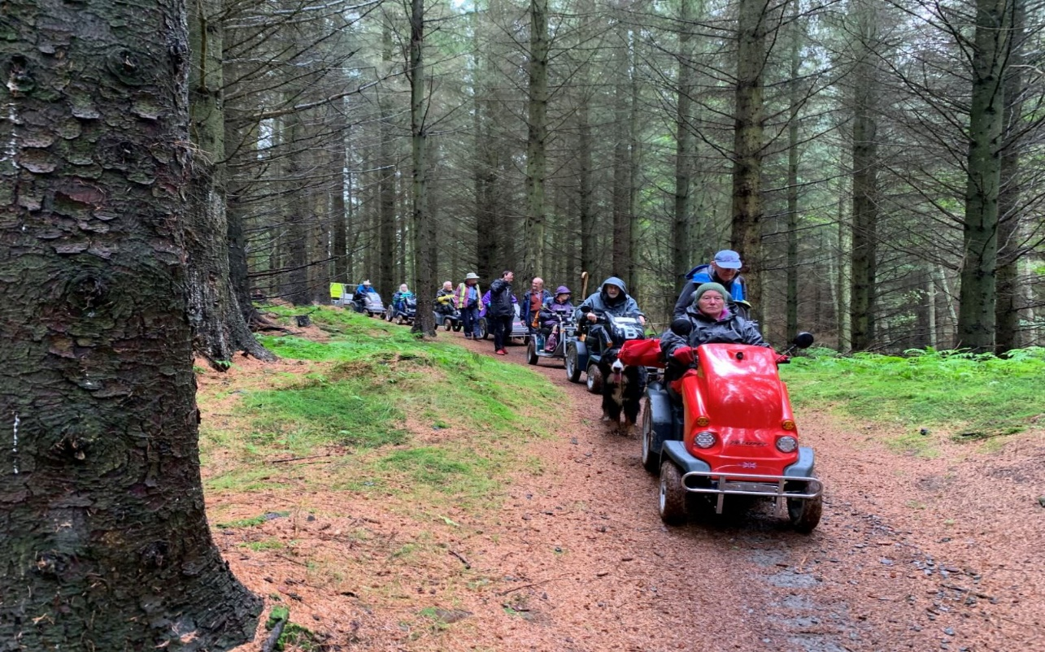
Tweed Valley 2019. If you go down to the woods today….!
Important Information
Routes: We do not warrant the condition of any route. Each person, disabled or able-bodied, is responsible for deciding where he or she feels able to go. Members are entirely responsible for their guests (walkers) and for keeping them with the ramble party.
Helping on difficult paths: While help in pushing scooters out of mud is appreciated, with permission of the scooter rider and while wearing a face covering, walkers should keep well out of the way when riders are negotiating a difficult section of path. These scooters are very powerful and heavy and cannot be stopped or moved by a person. Give the riders a clear path for them to choose their own route.
Helping and Touching: Please remind your guests that before helping anyone on a ramble, they should first ask that person if they would like help, and how they would like to be helped. Anyone helping must wear a face covering. As well as being courteous, not everyone wants, or even needs, help. Also, there are often medical reasons why an individual member needs to be approached or touched in a particular way - or not touched at all.
Help with Care or Moving: We have no paid staff and any able-bodied people accompanying us are volunteers, friends, family and sometimes, carers of our members. They frequently help us by holding gates or seeing us across roads but are not expected or trained to lift people or provide care to others. If you need help with unloading or loading your scooter, personal care, or transferring etc. you must bring a Carer with you.
Medical: Anyone with a condition which could involve an unusual emergency response should understand that there may be no mobile phone reception where we are rambling. Please consider this before booking on a ramble.
Age: All under 18s must be accompanied by an adult who will be responsible for them. Drivers of powered mobility vehicles must be at least 14 years old. Loan Scooter users must be at least 18.
Toilets: Our accessible toilets use a Porta Potti. Hand rails are provided. Access is from your scooter. We provide baby wipes and an alcohol spray in lieu of water for your hands. We aim to have an Accessible Toilet at the start, lunch stop and finish of each ramble. Please note this cannot be guaranteed. This will be confirmed prior to the ramble in the joining instructions.
Dogs: Welcome on most rambles.
Assistance Dogs may be present on all of our rambles. Please do not distract these working dogs – ask permission from the owners first if you want to talk to the dogs.
Emergencies: We do not provide first aid. You are encouraged to carry a small First Aid kit & Space Blanket with you. We will endeavour to call the emergency services if the situation requires.
Scooter Breakdown: In this rare event, we will try to get your scooter to a suitable point for recovery.
Please Note New Fees were introduced in 2020: Ramble Fee: £8 for each ramble per scooter rider.
Accompanying walkers free.
Loan Scooter Fee: £20 per day.
Booking Loan Scooters: Loans are limited to 8 rambles a year unless there is spare capacity. New members have priority when booking opens. New Loan Scooter users will be given instruction and a brief assessment on the day when they first use a Loan Scooter. Return completed Loan Scooter Terms of Use and Medical Questionnaire with your first Loan Scooter booking of the year.
Cancellation of a booked ramble or Loan Scooter: Please let Bookings know as soon as possible if you need to cancel: bookings@disabledramblers.co.uk We hope you will donate your fee. However, if you wish, it can be set against another ramble during this year or be refunded – send your bank Account Number & Sort Code and we will pay it in, or if necessary, a cheque will be raised. If you don’t let us know we will assume that you are happy to donate your fee to our charity.
Registered Charity No: 1103508

CAMPAIGNING FOR ACCESS FOR ALL
In addition to organising rambles for disabled people, the Disabled Ramblers are heavily involved in educating land managers and national & local authorities so that they better understand what can be achieved with modern mobility equipment.
Our key need is the removal of man-made barriers, such as stiles, gates and steps.
Read more about us and see our photos on our website.
THANK YOU
The Disabled Ramblers, would like to thank:
- all members & volunteer helpers for their roles in supporting these events.
- all Rangers and others who help us in the safe conduct of our rambles

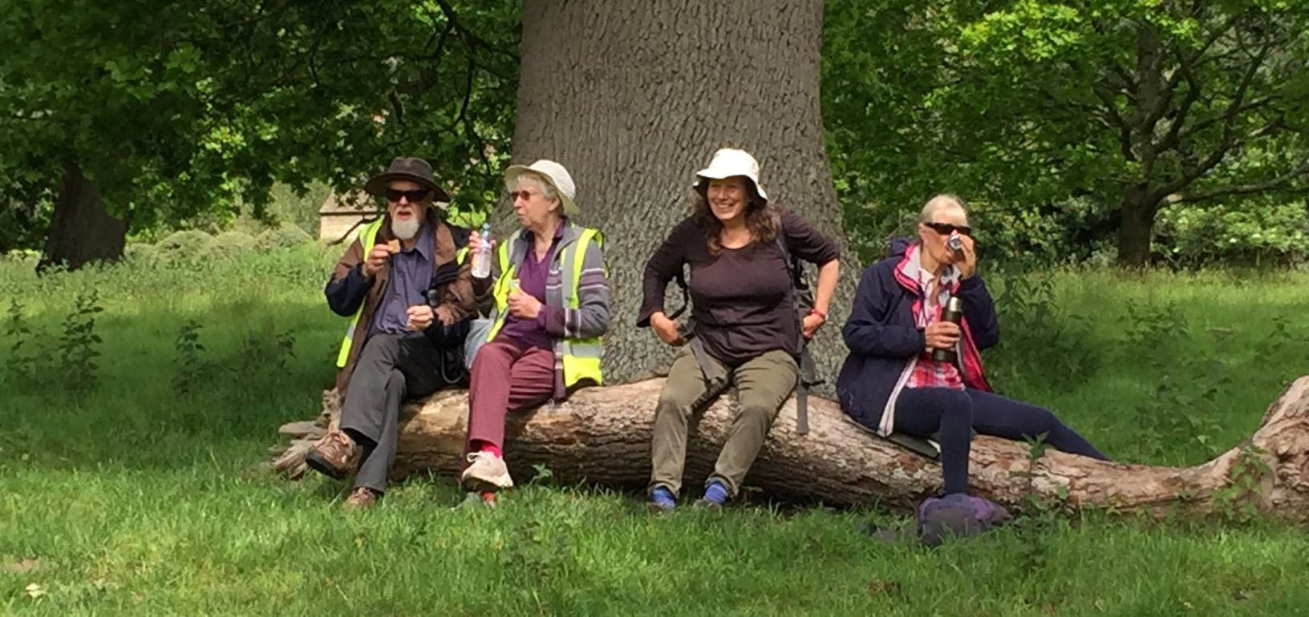
Some of our lovely volunteers having a well-earned rest

